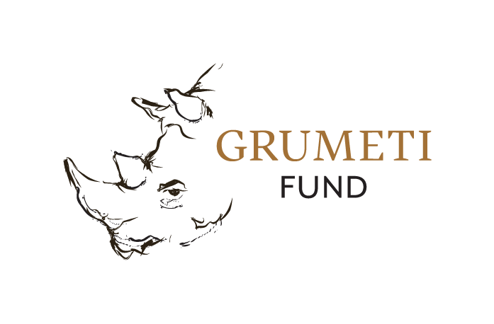
Women in the Field Application Form

Name: Phone number:

Email address:

Physical address

Region: Ward: Village:

Year of completion of A-levels:

Highest level of education obtained (select one):

___ A-level ___ Master’s (some)
___ Bachelor’s (some) ___ Master’s (completed)
___ Bachelor’s (completed)

Provide a brief description of your current employment:

List previous employers or relevant volunteer experience (organization name + start/end dates, maximum of 3):

Briefly describe your career goals:

Briefly describe what motivated you to apply for this program:

How did you hear about this program?

Of the following types of equipment, which do you have previous experience using? Experience does not influence selection and is for planning purposes only.
___ Binoculars ___ Excel
___ Camera ___ GPS
___ Compass ___ VHF receiver
___ Electronic device (smart phone or tablet) ___ Wildlife cameras (camera trap)

Of the following, which skills would you be most interested in developing? Select three:

___ The ethics of non-invasive human subjects research
___ Techniques and best practices for conducting household surveys
___ Conducting animal observations and recording relevant data
___ Tracking and locating animals
___ Setting up and recording data from wildlife cameras
___ How to operate safely and confidently in the field
___ Approaches for organizing research logistics, like budgeting and scheduling
___ Professional skills, like making a CV and formal communications

